

3rd year Computer and System
Multiple Rocket Launcher System (Raad 200 Maquette)
VHDL Report
Dr. Mohamed El-Bably
Section Number | Student Name
2 | Abdullah Sherif Mahmoud Dakroury
2 | Seif Ashraf Fawzy Roshdy
3 | Hager Essam Gaber Mahmoud
3 | Mariam Ashraf Hassan Mohamed
Team – Members
▪ Table of Contents

- Multiple Rocket Launcher System…........................3
- ASM ..................................................................4
- VHDL CODE............................................................5
- VHDL CODE (Testbench)......................................10
- The process of the VHDL code………………………..12
- ASIC Chip ...........................................................13
- I/P & O/P BehavioralSimulation…........................14
- References .........................................................17

Multiple Rocket Launcher System
A Multiple Rocket Launcher System (MRLS) is a type of artillery system that is designed to launch multiple rockets in rapid succession to deliver a large volume of firepower over a wide area. These systems are often used in military applications for both offensive and defensive operations, capable of targeting both fixed and moving targets over long distances.

Key Features of MRLS:
- Multiple Launch Tubes: The MRLS has multiple tubes (usually ranging from 6 to 12 or more) mounted on a single vehicle or platform. Each tube can fire a rocket individually or in rapid succession.
- High Rate of Fire: One of the main advantages of MRLS is the ability to deliver a large number of rockets in a short time, allowing for saturation bombardment, which can overwhelm enemy defenses.
- Variety of Rockets: MRLS can fire a variety of rockets, including guided and unguided rockets. These rockets can be designed for different purposes such as anti-personnel, anti-armor, or precision strikes. Some systems can fire ballistic missiles or even cluster munition rockets.
- Mobility: Many MRLS platforms are mounted on wheeled or tracked vehicles, making them highly mobile and capable of quickly relocating to different positions to avoid counterattacks.
- Area Effect: The rockets fired from MRLS are designed to cover a large area, making them effective for suppressing enemy troops, vehicles, or artillery in a wide radius.
- Targeting and Guidance: While early MRLS used unguided rockets, modern systems can integrate advanced targeting and guidance systems, improving accuracy and allowing for precision strikes.
Algorithmic State Machine (ASM) of
Multiple Rocket Launcher System

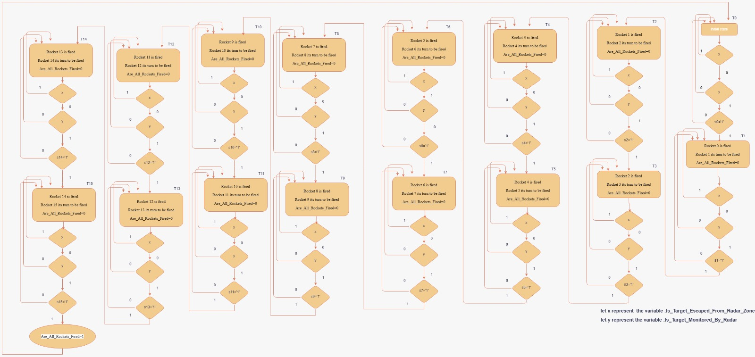

VHDL Code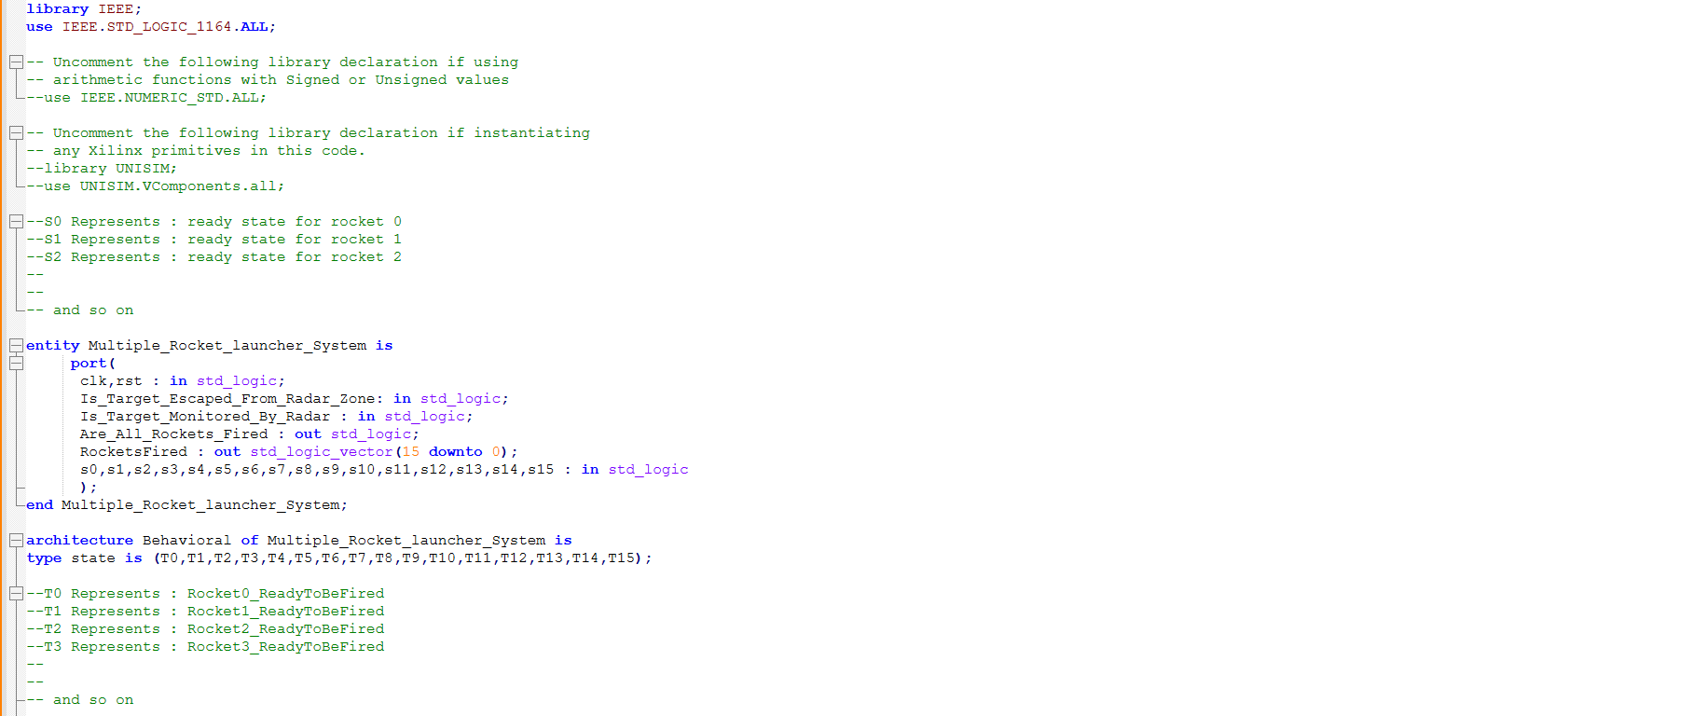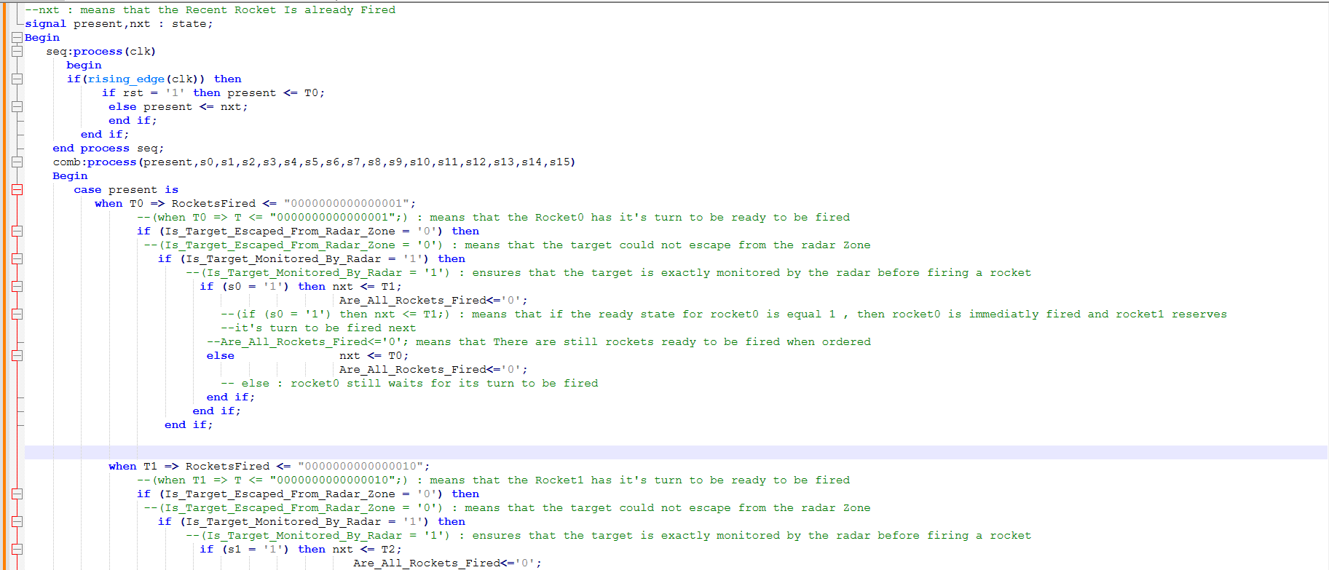
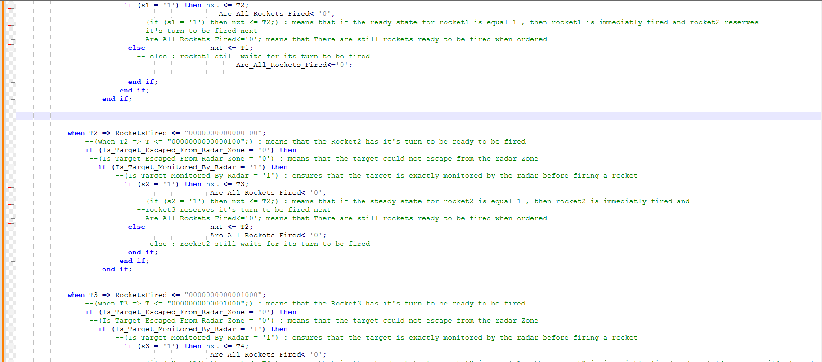

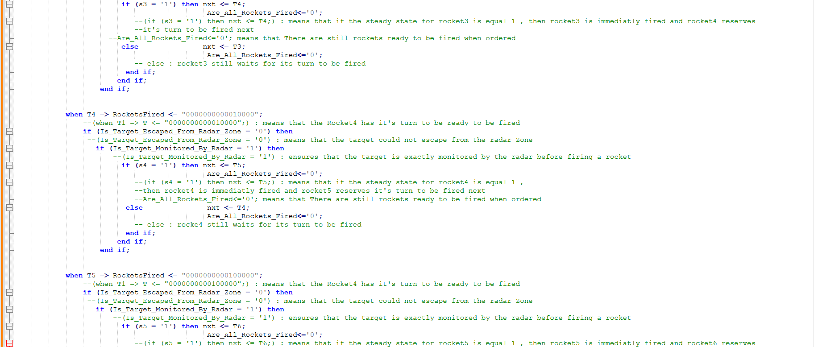

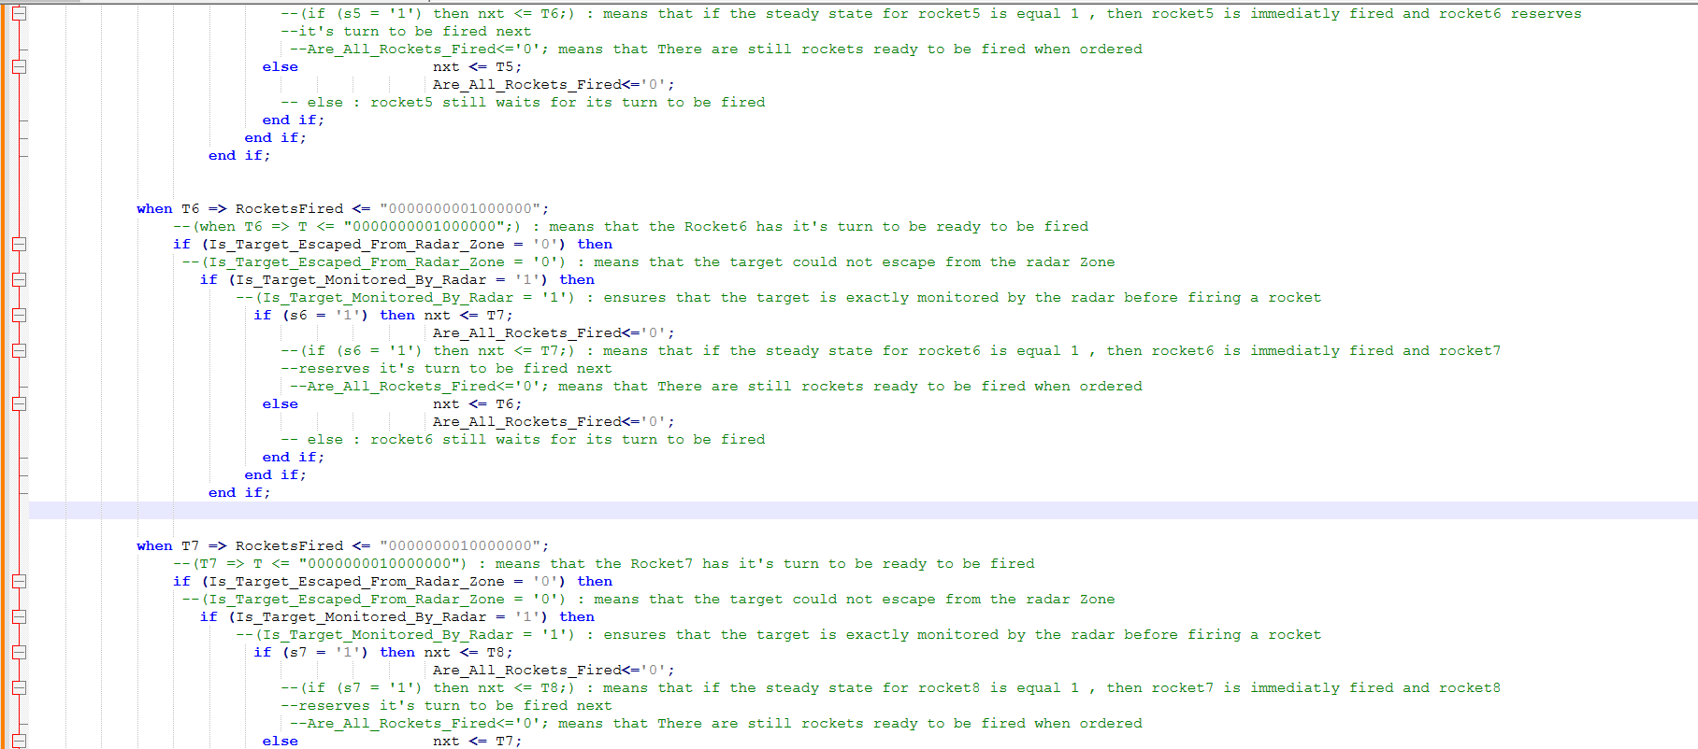
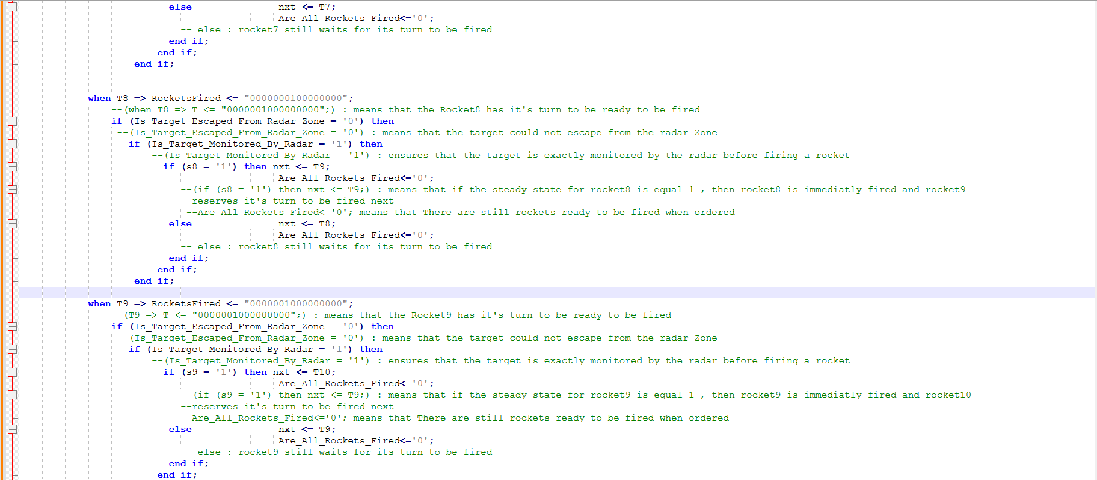
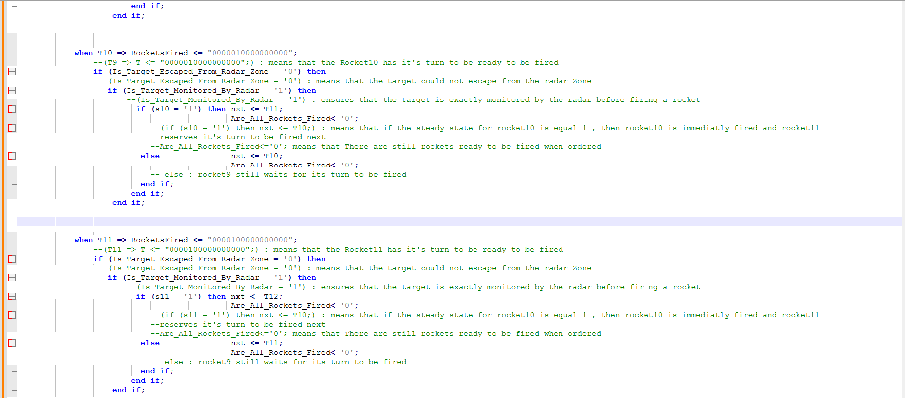
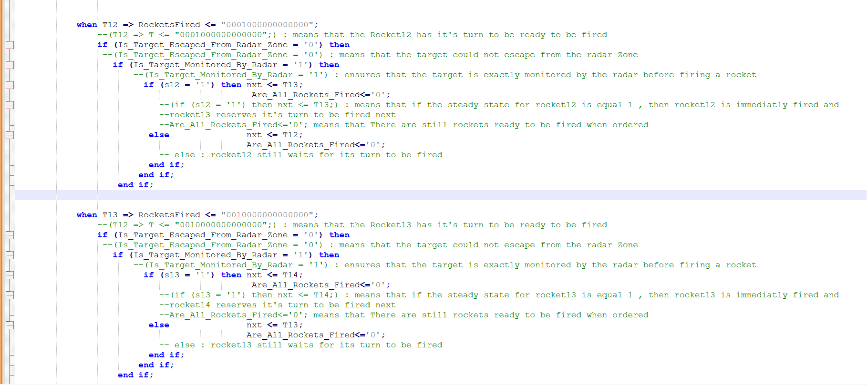
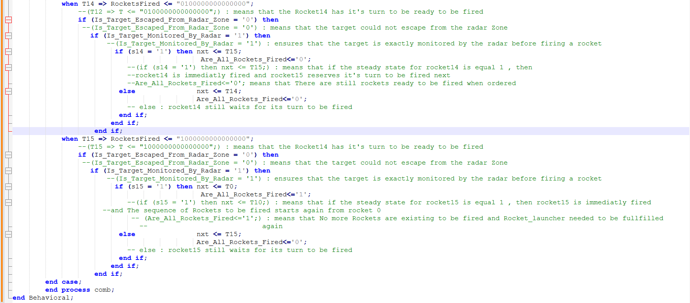
VHDL CODE (Testbench)
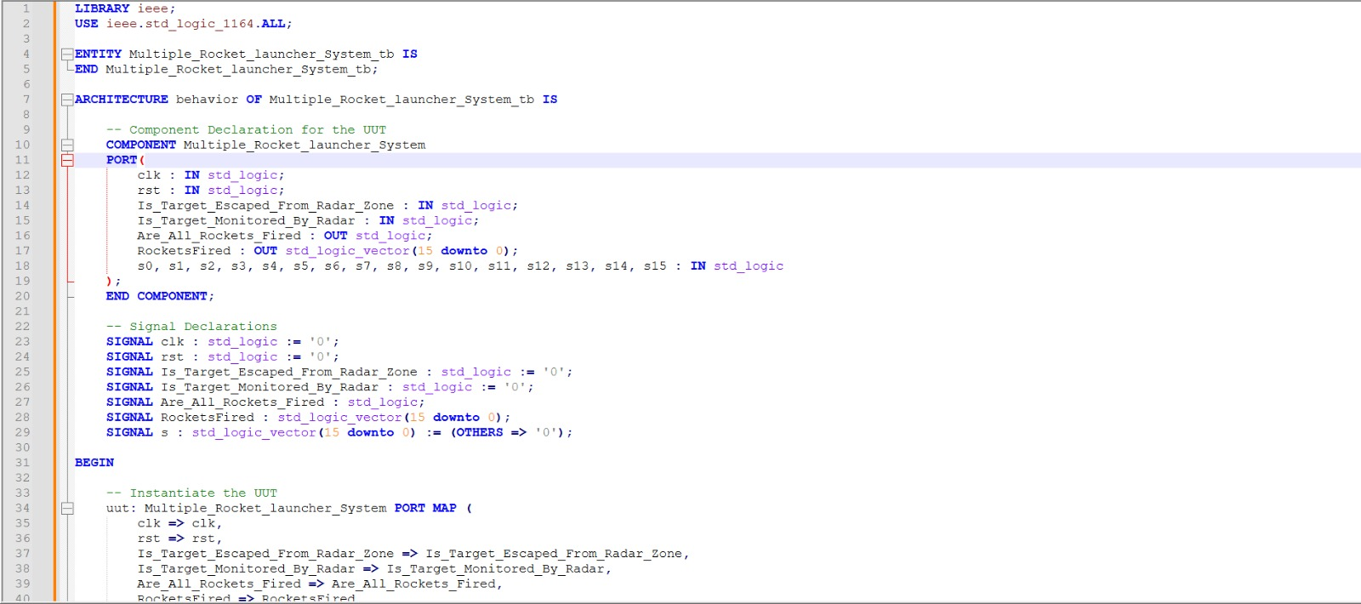
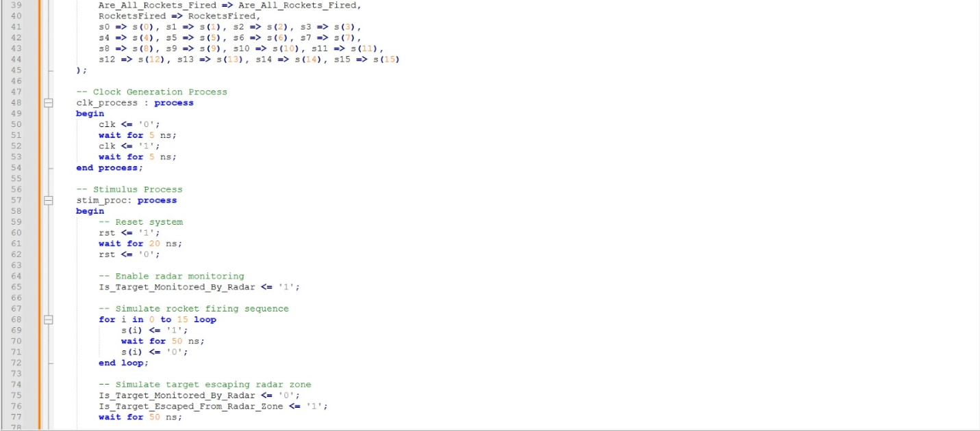
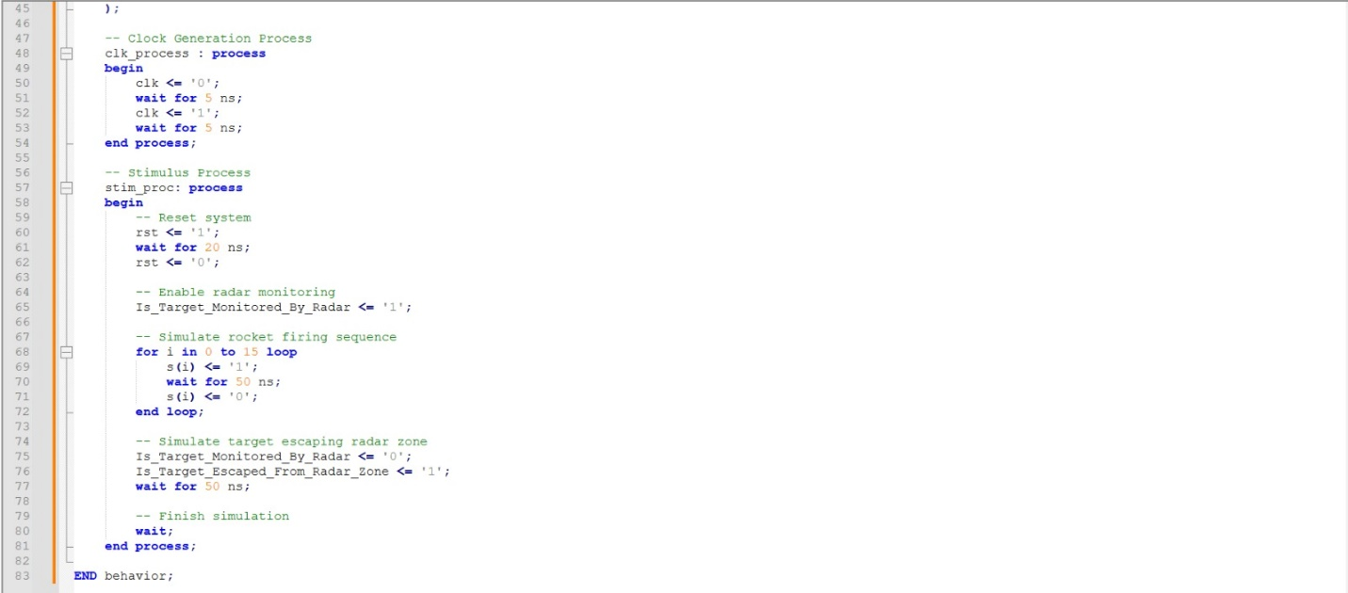

❖ The process of the VHDL code:
• The code is synchronous, so the process is the function of clock (clk). And also reset control line is used (rst).
• Conditions for the operations are (S0 to S15).
--S0 Represents : ready state for rocket 0
--S1 Represents : ready state for rocket 1
-- and so on
• (Are_All_Rockets_Fired) is used to check if the “Multiple Rocket Launcher System” is ran out of rockets and becomes unable to hit targets until being fulfilled with rockets again
• From T0 to T15 is the states in the code
--T0 Represents : Rocket0_ReadyToBeFired
-- and so on
• We have two signals (pr, nxt) used to identify the current and the next state of the “Multiple Rocket Launcher System” within processing.
❖ RTL Schematic Diagram :
(ASIC Chip)
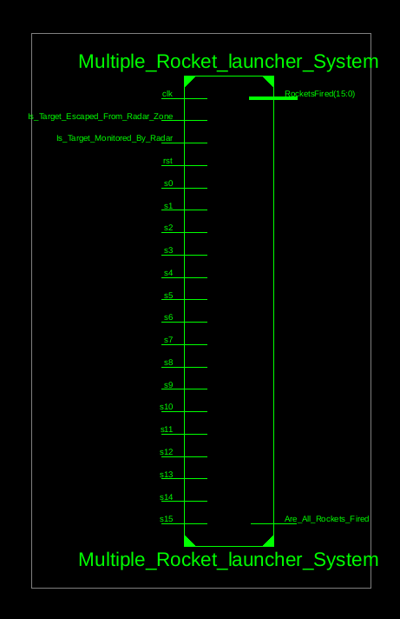
❖ I/P & O/P Behavioral Simulation:
- Ready state of rockets before being fired
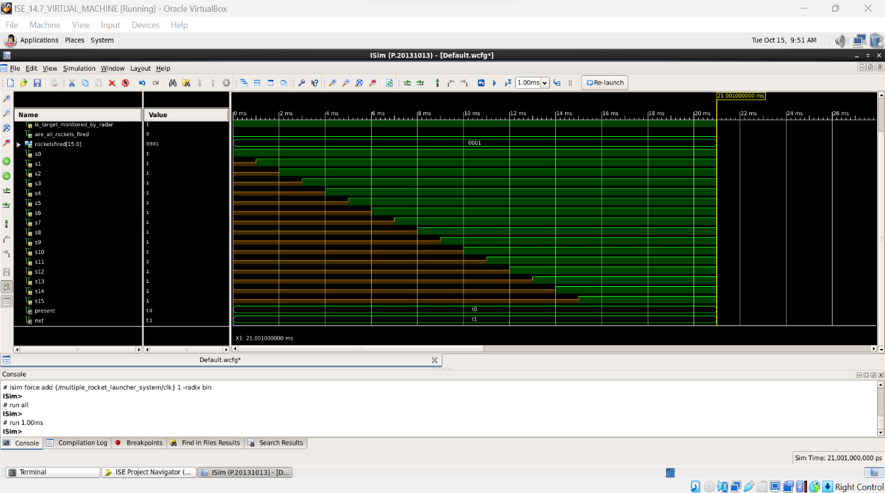
B)Rockets being fired in sequence
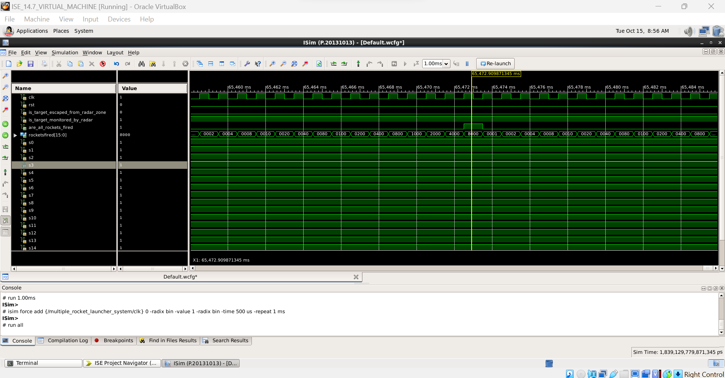

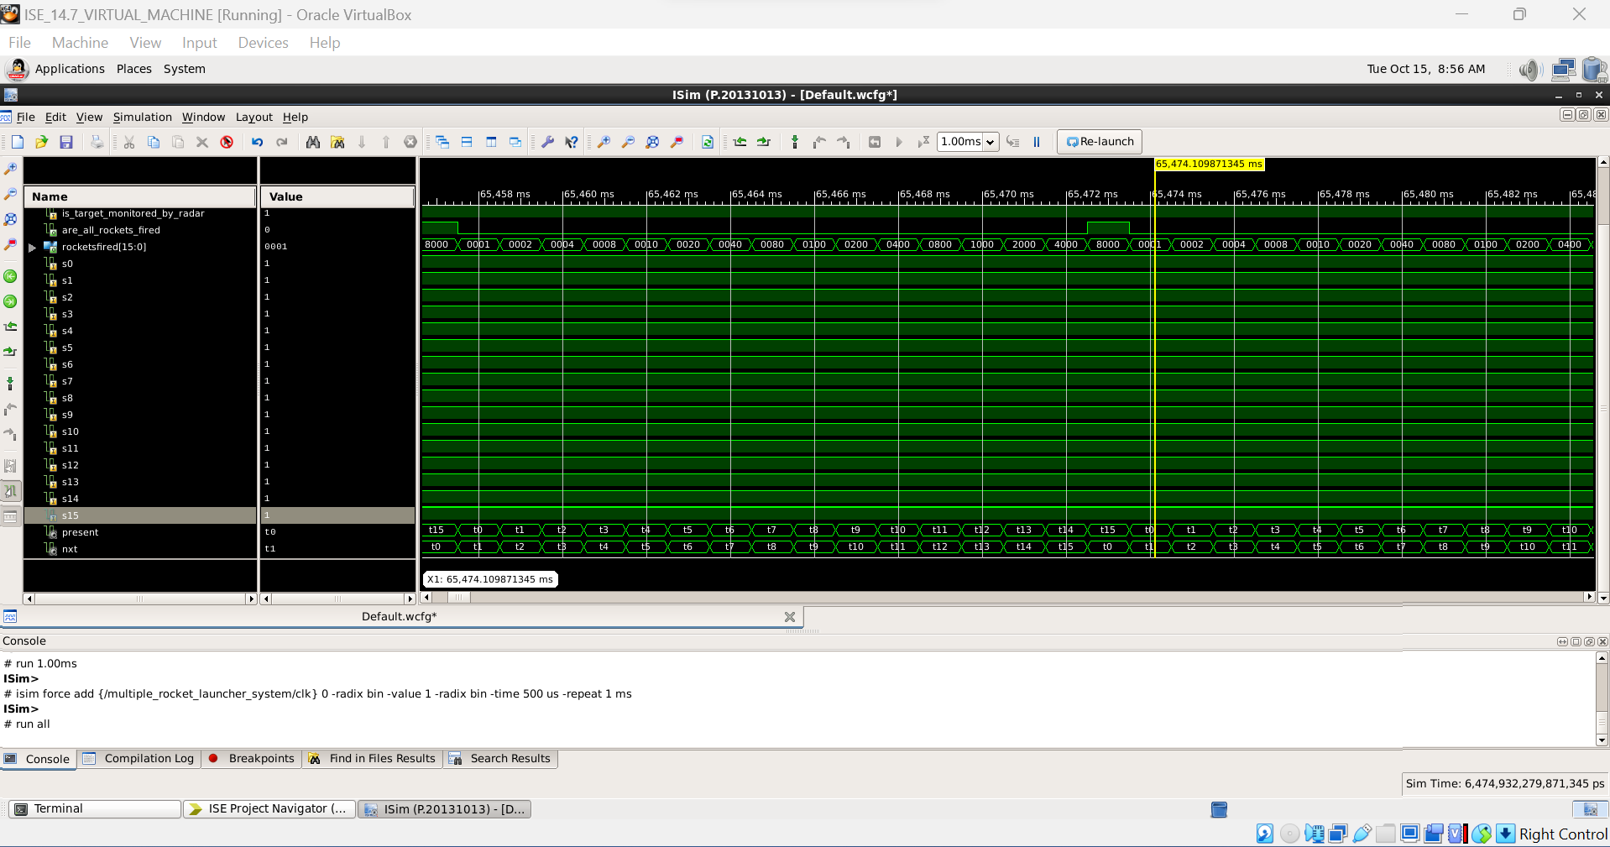

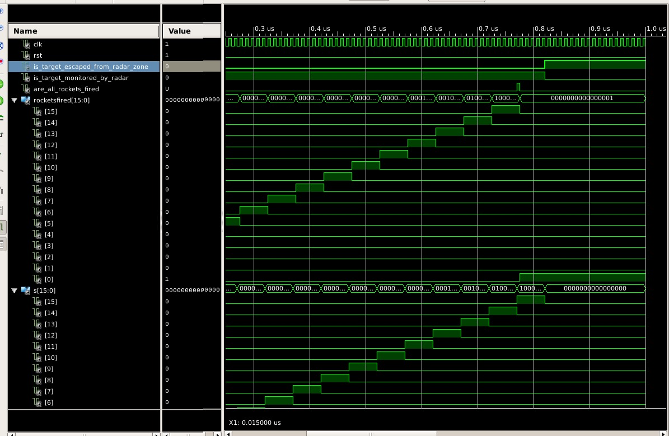
c)Testbench

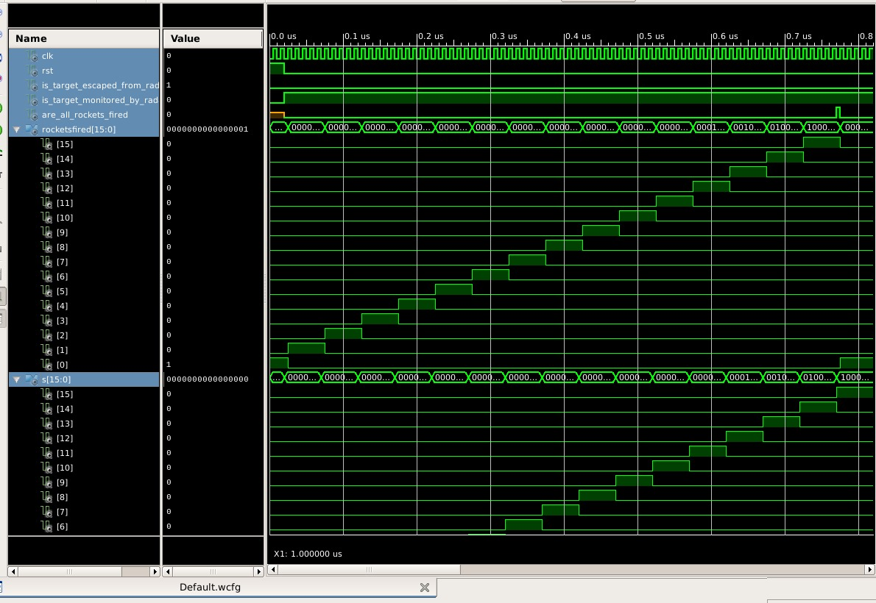
References:
• Raad 200 Egyptian Multiple Rocket Launcher
https://www.youtube.com/watch?v=Zl1o4THIMwM
• Top 10 Multiple Launch Rocket Systems | Best MLRS in the World
https://www.youtube.com/watch?v=LAX9baooYuk“Macquette”
• Arduino Missile Defense Radar System in ACTION
https://www.youtube.com/watch?v=ahhb5EjHleY

